19162121031

SMIT R PATEL

SME 5

HBASE PRACTICAL

BDA

AIM- To understand basic commands in HBase.

Exercise: In order to work with an ‘unstructured data’ containing file, your sibling wants you to

help her work in Hadoop. She realises that she might need to modify data and have random

reads/writes, which traditional HDFS would not help with. Give her a solution and provide a

way for her to work through this problem while teaching her how to work with that tool.

Tasks:-

1. Open the HBase shell and create a table with a column family.

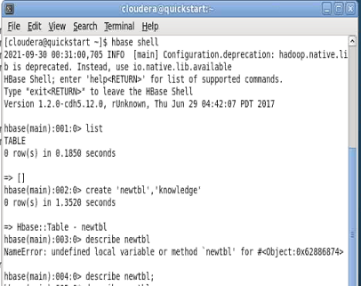

2. Work inside that column family and create columns with values.

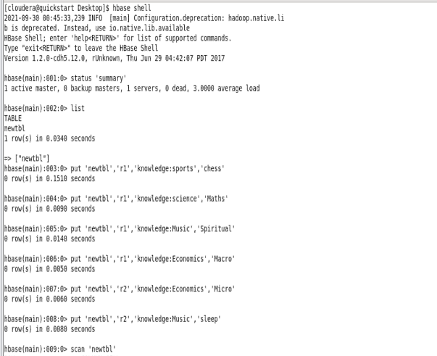

3. Query data from the above-mentioned table.

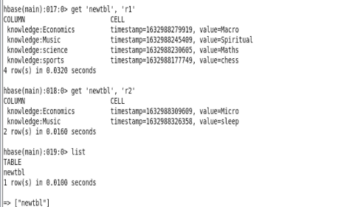

4. Give commands for enabling and disabling the table, and also alter data values inside it.

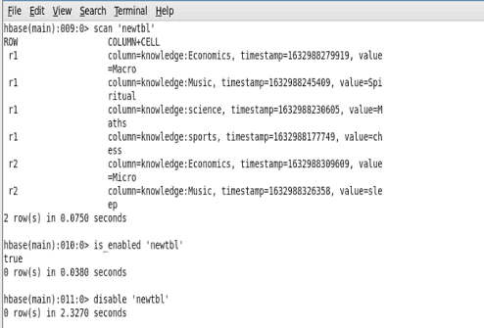

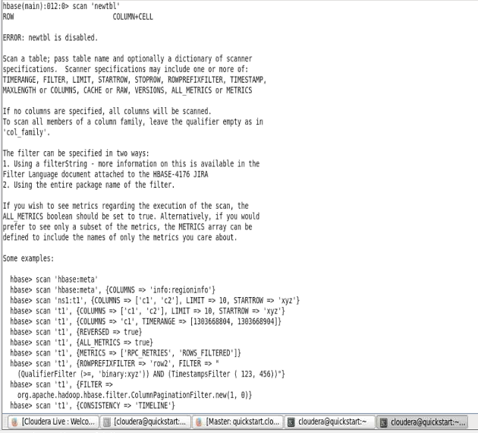

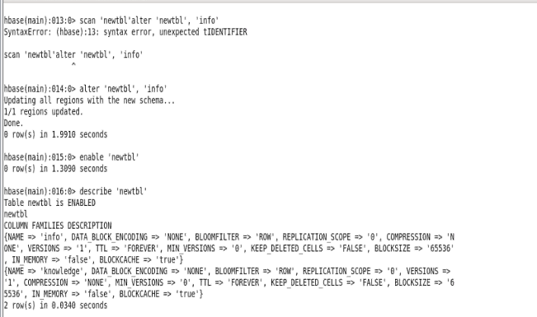

Extra ;-

